Microservices Architecture – Fundamentals to Advanced
(Week 2 – Day 1)

Introduction: What Is Microservices Architecture
Microservices architecture is a software design approach in which a large application is broken down into smaller, independent services. Each service focuses on a single business capability and runs as its own application. This means every microservice has its own process, memory, CPU usage, and network port. These services communicate with each other using lightweight mechanisms, most commonly HTTP or messaging systems.
The core idea behind microservices is independence. Each service can be developed, deployed, scaled, and maintained without depending on other services. This is especially important in large systems where different features evolve at different speeds and receive different amounts of traffic.
Microservices are used because modern applications are complex, long-running, and continuously evolving. A single large codebase becomes difficult to maintain, slow to deploy, and risky to change. Microservices solve these problems by breaking the system into manageable, autonomous parts.

Architectures Before Microservices and Why They Were Not Enough
Before microservices, most applications followed the monolithic architecture. In a monolith, the entire application is built as one single unit. All features—authentication, payments, profiles, notifications, and business logic—exist in one codebase and are deployed together. Even a small change requires rebuilding and redeploying the entire application. As the application grows, this leads to slow development, higher chances of failure, and long downtimes.
To improve this, Service-Oriented Architecture (SOA) was introduced. SOA attempted to split applications into services, but relied heavily on centralized components like Enterprise Service Bus (ESB). The ESB handled routing, transformations, and sometimes even business logic. Over time, this central intelligence became a bottleneck, difficult to maintain, and a single point of failure.
Microservices were introduced to remove heavy central systems and push intelligence to the services themselves.

Microservices Principles (Martin Fowler & James Lewis)
Martin Fowler and James Lewis defined a set of principles in 2014 to describe what truly makes a system microservice-based. A project does not need to follow every principle perfectly, but following most of them indicates a genuine microservices architecture. These principles exist to solve real engineering problems seen in large-scale systems.
The most important principles discussed here are grouped logically so they are easy to understand and remember.

Principle 1: Componentization via Services
Componentization via services means the application is broken into multiple independent services instead of being divided into modules inside a single application. Each microservice is a standalone deployable unit.
In a monolithic system, if one small change is made, the entire application must be rebuilt and restarted. This affects all users, even those using unrelated features. In microservices, if a change is needed in one service, only that service is redeployed. Other services continue running without interruption.
This principle also enables independent scaling. If one service receives heavy traffic, only that service needs additional resources. The rest of the system remains unchanged. This leads to better performance, reduced cost, and higher availability.

Principle 2: Organized Around Business Capability
Microservices are organized around business capabilities, not technical layers. This means each service represents a complete business function, such as payments, orders, users, or notifications.
Earlier systems were organized by technical layers—frontend teams, backend teams, database teams. This caused dependencies between teams and slowed down development. In microservices, one team owns one service completely, including APIs, business logic, and database interactions.
This approach improves ownership, accountability, and speed. Teams can make decisions independently and see the long-term impact of their design choices.

Principle 3: Smart Endpoints and Dumb Pipes
This principle states that microservices should contain their own business logic, while the communication mechanism between services should remain simple. The service endpoints are smart, and the communication pipes are dumb.
In SOA, centralized systems like ESB contained business logic, routing rules, and transformations. This made systems tightly coupled and difficult to change. Microservices avoid this by using simple communication protocols such as REST over HTTP.
Each service is responsible for its own logic and decision-making. The communication layer simply transfers data without applying business rules.

Communication Between Microservices
Synchronous Communication
Synchronous communication means one service sends a request to another service and waits for a response before continuing execution. This is similar to making a phone call and waiting for the other person to reply.
In Spring Boot, synchronous communication is implemented using HTTP clients. Earlier libraries like RestTemplate and FeignClient were widely used. Newer approaches include RestClient and HTTP Interface clients, which provide cleaner APIs and better maintainability.
Synchronous communication is used when an immediate response is required, such as validating user data or checking payment status. However, it increases coupling because if the destination service is slow or unavailable, the calling service is also blocked.
Asynchronous Communication Using Message Brokers
Asynchronous communication means the sender does not wait for the receiver to complete processing. The sender sends a message and continues execution immediately.
This is achieved using message brokers such as Kafka, ActiveMQ, or RabbitMQ. These systems store messages and deliver them to consumers when they are ready.
In Java and Spring applications, JMS (Java Message Service) is used as the API to interact with message brokers. JMS is not a broker itself; it is a specification that allows applications to send and receive messages reliably.
Asynchronous communication is used when the sender does not need an immediate response or when systems must remain loosely coupled.
Reactive Style of Communication
Reactive communication is another asynchronous approach that avoids blocking threads. Instead of waiting for responses, the system processes events in a non-blocking manner.
Spring provides WebFlux and WebClient for reactive programming. Reactive systems use fewer threads and handle high concurrency more efficiently. This makes them suitable for high-load, I/O-bound applications.

Principle 4: Design for Failure
In distributed systems, failures are inevitable. Networks fail, services crash, and dependencies slow down. If systems are not designed for failure, a single issue can cause cascading failures across the entire system.
Designing for failure means assuming failures will happen and building mechanisms to handle them gracefully.
Circuit Breaker Mechanism
A circuit breaker prevents repeated calls to a failing service. When failures exceed a threshold, the circuit opens and stops further calls temporarily. This allows the failing service time to recover and protects the rest of the system.
Spring Boot uses libraries such as Resilience4j to implement circuit breakers.
Scaling and Multiple Instances
When traffic increases, scaling is achieved by running multiple instances of the same microservice, not by creating new microservices. Each instance handles part of the traffic, and a load balancer distributes requests.
This is known as horizontal scaling. While effective, it introduces challenges in logging and monitoring.
Centralized Logging and ELK
In a scaled system, logs are spread across multiple instances and machines. Without centralized logging, debugging becomes impossible.
ELK solves this problem. Elasticsearch stores logs, Logstash collects and processes logs, and Kibana provides visualization. This allows tracing a single request across multiple services even when instances scale up or down.

Summary
Microservices architecture exists to solve scalability, maintainability, and reliability problems of large systems. By organizing services around business capabilities, using simple communication mechanisms, handling failures gracefully, and designing for scalability, microservices enable teams to build robust, production-ready systems.
These principles form the foundation for modern backend systems and are essential for understanding real-world projects, interviews, and production environments.

SPRING AND SPRINGBOOT
(Week 2 – Day 2)

- First let’s see an example, assume

If we use @Component in the class,
and then in controller we are creating another object of that class using new,
and then calling the method of that class inside controller,
which object will be used?
The one created by Spring?
Or the one that we created using new?
And why?

ANSWER ->

Okay 👍 let’s use your exact situation.
You said:
- You put @Component on a class.
- In the controller, you also did new for that same class.
- Then you called its method.
- You’re asking which object is used.
Let’s write your situation clearly.

Your Class
@Component
public class A {

public void show() {
System.out.println("Hello");
}
}
Now Spring creates one object of A internally.

Your Controller (your example — using new)
@RestController
public class MyController {

A obj = new A(); // you created manually

@GetMapping("/test")
public String test() {
obj.show();
return "done";
}
}

Now what is happening?

There are two objects of A:
- One created by Spring because of @Component
- One created by you using new A()
When you call:
obj.show();
It uses the object you created using new.
Spring’s object is just sitting inside the container unused.

If You Actually Want Spring’s Object (Constructor Injection)
@RestController
public class MyController {

private final A obj;

public MyController(A obj) { // constructor injection
this.obj = obj;
}

@GetMapping("/test")
public String test() {
obj.show();
return "done";
}
}
Now:
- You did NOT create the object.
- Spring creates A.
- Spring creates MyController.
- Spring injects its bean into the constructor.
- The method runs on the Spring-managed object.
Only one object of A is used.

Same Thing Using @Autowired (Field Injection)
@RestController
public class MyController {

@Autowired
A obj;

@GetMapping("/test")
public String test() {
obj.show();
return "done";
}
}
Here also:
- Spring injects its created bean.
- You do not use new.
- The method runs on the Spring-managed object.

Why Creating with new Is a Blunder in Frameworks
You said:
we started using framework to ease that part
Exactly.
Spring exists to:
- Create objects
- Manage dependencies
- Control lifecycle
- Apply transactions
- Apply AOP
If you write:
A obj = new A();
You are bypassing the whole framework.
That means:
- If A had @Autowired, it won’t work.
- If A had @Transactional, it won’t work.
- If A had AOP, it won’t work.
- If A needed configuration values, they won’t inject.
So yes — for Spring-managed classes, creating objects manually defeats the purpose of using the framework.

Final Answer Using Your Example
The method will run on the object you created using new, not the one created by Spring.
If you want the Spring one, you must inject it (constructor injection is recommended in modern Spring applications).

- Now, some definitios for interview ->

1️⃣ @Component
Definition:
@Component tells Spring that this class should be created and managed by the Spring container.
In simple words:
It means:
“Spring, please create an object of this class and manage it for me.”
When Spring starts:
- It scans the project.
- It finds classes marked with @Component.
- It creates objects of them.
- It stores them inside the container (ApplicationContext).
So @Component makes a class a Spring-managed bean.

2️⃣ @Autowired
Definition:
@Autowired tells Spring to automatically inject the required dependency into a class.
In simple words:
It means:
“Spring, give me the object you already created.”
Instead of doing:
A obj = new A();
You let Spring provide the object:
@Autowired
A obj;
Spring finds the matching bean and injects it.

3️⃣ Dependency Injection (DI)
Definition:
Dependency Injection is a design pattern where an object receives its dependencies from outside instead of creating them itself.
In simple words:
Normally:
class B {
A a = new A(); // B creates A
}
Here B is tightly connected to A.
With Dependency Injection:
class B {
A a;

public B(A a) {
this.a = a;
}
}
Now B does not create A.
It receives A from outside.
So:
Dependency Injection means giving required objects from outside instead of creating them inside the class.
Spring performs DI automatically.

4️⃣ Inversion of Control (IoC)
Definition:
Inversion of Control means transferring the control of object creation and management from the application code to the framework.
In simple words:
Normally in Java:
- You create objects.
- You control everything.
With Spring:
- Spring creates objects.
- Spring manages them.
- Spring injects them.
So control is inverted.
Instead of:
“I create and control objects.”
It becomes:
“Spring creates and controls objects.”
Dependency Injection is one way Spring achieves IoC.

🔥 Short Interview Summary (Very Crisp)
- @Component → Marks a class as a Spring-managed bean.
- @Autowired → Injects a dependency automatically.
- Dependency Injection → Giving required objects from outside instead of creating them.
- Inversion of Control → Framework controls object creation instead of you.

- Explain Dependency Injection, Bean Creation Flow, and Constructor Injection in Spring

Your understanding is mostly correct 👍 but a few things needed structuring for clarity.

1️⃣ What are you dependent on?
- A Controller depends on a Service
- A Service may depend on a Repository
Example:
@RestController
public class AddController {

private AddService addService;

}
AddController cannot function without AddService.
So AddService is its dependency.

2️⃣ What is a Dependency?
A dependency means:
One class requires another class to perform its work.
Controller → depends on Service
Service → depends on Repository
These terms are relative, not fixed.
- A class is a dependent if it depends on another class.
- A class is a dependency if something else depends on it.
Example:
Controller → depends on Service
Controller = Dependent
Service = Dependency
Service → depends on Repository
Service = Dependent
Repository = Dependency
So roles change based on direction.

3️⃣ Before Spring (Manual Object Creation)
AddService addService = new AddServiceImpl();
This means:
- AddService → interface (reference type)
- AddServiceImpl → implementation class
- Controller creates its own dependency
This creates tight coupling because the controller decides which implementation to use.

4️⃣ With Spring (IoC Container)
@Autowired
AddService addService;
Now Spring:
- Scans annotated classes
- Creates beans inside the IoC container
- Manages their lifecycle
- Injects dependencies automatically
The controller no longer creates the object — Spring does.

5️⃣ How Bean Creation Actually Happens
Spring does not randomly create the controller first.
What happens:
- Spring scans classes annotated with:
  - @Controller
  - @Service
  - @Component
  - @Repository
- It creates beans inside the IoC container.
- While creating a bean (e.g., Controller), Spring checks if it depends on another bean.
- If dependency exists:
  - It finds the required bean
  - Or creates it first
  - Then injects it
Dependency resolution happens during bean creation.

6️⃣ How Can One Spring Bean Access Another Spring Bean?
One Spring bean accesses another in two ways:
- Dependency Injection (DI)
- Dependency Lookup (DL)
Beans do not create each other manually.
Instead:
- A bean declares what it needs.
- The Spring container connects them.
- The container either injects the required bean (DI)
OR the bean asks the container for it (DL)
This is how communication happens between beans.

7️⃣ What is Dependency Injection (DI)?
Dependency Injection means:
The Spring container provides the required object to your class.
The class does not create the object using new, and it does not search for it.
There are multiple ways to perform DI:
- Constructor Injection
- Field Injection
- Setter (Method) Injection
- Parameter Injection

✅ Method 1: Constructor Injection (Recommended)

@Autowired is optional at constructor level.
spring will automatically provide the needed spring bean to you.

@RestController
public class AddController {

private final AddService addService;

public AddController(AddService addService) {
this.addService = addService;
}
}
Flow:
- Spring creates the AddService bean.
- Spring calls the constructor.
- this.addService = addService; assigns it.
- The controller can safely use it.
If you declare the field but never assign it, it remains null, and calling a method causes a NullPointerException.
Constructor injection is preferred because:
- It ensures dependency is required.
- It improves testability.
- It promotes loose coupling.

✅ Method 2: Field Injection
@RestController
public class AddController {

@Autowired
private AddService addService;

}
Flow:
- Spring creates the AddService bean.
- Spring injects it directly into the field.
- You do not write this.addService = addService;.
- Spring assigns it internally.
Both approaches are DI. Constructor injection is generally recommended.

If we try to access the object inside the constructor, then in constructor injection it works because Spring passes the object while calling the constructor, so it is already created and not null. But in field injection using @Autowired, the constructor runs first and the object is injected only after that, so if we try to access the object inside the constructor, it will be null and can cause a NullPointerException.

✅ Method 3: Setter (Method) Injection
Spring can inject dependency using a setter method.
@Autowired
public void setAddService(AddService addService) {
this.addService = addService;
}
Spring calls the setter method and assigns the dependency.

✅ Method 4: Parameter Injection
Spring can inject dependencies directly into method parameters, commonly used in @Bean methods or controller handler methods.
Example:
@Bean
public SomeBean someBean(AddService addService) {
return new SomeBean(addService);
}
Here Spring injects the dependency into the method parameter.

8️⃣ What is Dependency Lookup (DL)?
Dependency Lookup means:
The class itself asks the container for the dependency.
Example:
ApplicationContext context =
new AnnotationConfigApplicationContext(Config.class);

AddService service = context.getBean(AddService.class);
Here:
- The object interacts directly with the container.
- It explicitly requests the dependency.
- It becomes more tightly coupled to Spring.
Not commonly used in modern Spring applications.

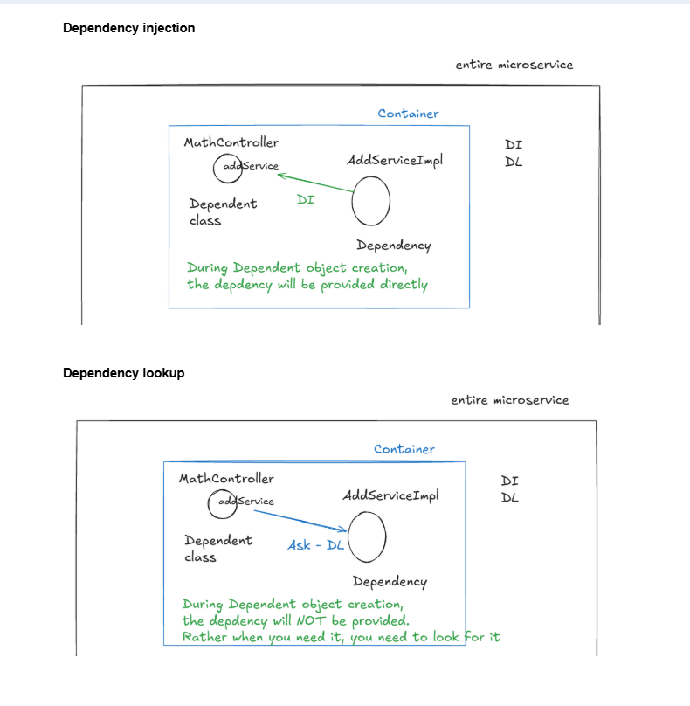

9️⃣ Why Dependency Injection Is Necessary
If you only declare:
AddService addService;
this does not create the object. It only creates a reference variable.
If Spring does not inject the dependency and you call:
addService.add();
you will get a NullPointerException because the reference is null.
So injection ensures the object is properly created and assigned before usage.

🔹 Why this.addService = addService; Is Important
this.addService = addService;
This line:
- Receives the dependency from Spring (constructor parameter)
- Assigns it to the class field
- Stores it for use throughout the class
If you remove this line:
- The constructor receives the object
- But the class field remains null
- Calling addService.add() later will cause NullPointerException
So this assignment connects the injected object to the controller.
Without it, constructor injection fails.

🔹 Final Understanding
- Spring creates and manages beans inside the IoC container.
- Beans communicate using DI or DL.
- DI has multiple forms: constructor, field, setter, and parameter injection.
- Dependent and dependency are relative terms.
- Injection prevents null references.
- Constructor injection is best practice.
- The assignment inside the constructor is essential.

Now the flow is logically ordered from:
Dependency → Manual creation → IoC → Bean creation → Bean communication (DI & DL) → Types of DI → Null problem → Best practice.

- Top IntelliJ Shortcuts for Backend Developers

1️⃣ Go to Declaration
Ctrl + B or Ctrl + Click
Jump to class, method, variable definition.

2️⃣ Go to Implementation
Ctrl + Alt + B
Very useful when working with interfaces (like Service or Repository).

3️⃣ Go to Super Method / Class
Ctrl + U
Navigate to parent method or superclass.

4️⃣ Type Hierarchy
Ctrl + H
See parent and child classes.

5️⃣ Search Everywhere ⭐
Shift + Shift
Search anything — class, file, setting, action.

6️⃣ Go to Class
Ctrl + N
Open any class (even inside libraries).

7️⃣ Go to File
Ctrl + Shift + N
Find and open any file.

8️⃣ Go to Symbol
Ctrl + Alt + Shift + N
Search method or variable across project.

9️⃣ Search in Entire Project
Ctrl + Shift + F
Find text anywhere in project.

🔟 Optimize Imports
Ctrl + Alt + O
Remove unused imports.

1️⃣1️⃣ Reformat Code ⭐
Ctrl + Alt + L
Formats your code properly (indentation, spacing, alignment).
Professional developers use this constantly before committing code.

1️⃣2️⃣ Delete Line
Ctrl + Y
Delete current line quickly.

1️⃣3️⃣ Duplicate Line
Ctrl + D
Duplicate current line.

1️⃣4️⃣ Move Line Up / Down
Alt + Shift + ↑ / ↓
Reorder lines easily.

1️⃣5️⃣ Auto Completion
Ctrl + Space → Basic suggestion
Ctrl + Shift + Space → Smart suggestion

1️⃣6️⃣ Quick Fix / Suggestions ⭐
Alt + Enter
Fix errors, add imports, create methods, refactor.

1️⃣7️⃣ Recent Files
Ctrl + E
Switch between recently opened files.

Here’s a shortened, interview-ready version with your requested line about @Value as a definition:

- Spring Bean Creation, Injection, and @Value – Key Concepts

1️⃣ Annotation Scanning and Bean Creation
When a Spring application starts:
- Spring scans all classes annotated with @Component, @Service, @Repository, or @Controller.
- For each annotated class, Spring creates an object (bean) using its constructor — default or defined.
- If the bean has an @Autowired field, Spring sees: “This bean needs another bean here.”
- If the dependent bean does not exist, Spring creates it first using its constructor.
- Once the dependent bean exists, Spring injects it into the @Autowired field.
This ensures all dependencies are satisfied while the bean is managed inside the IoC container.

2️⃣ Dependency Injection (DI) Types
Spring supports:
- Constructor injection
- Field injection
- Setter (method) injection
- Parameter injection
@Value is not a new DI type — it is generally used to read values from application.properties and can be injected using any of the above mechanisms.

@Value in Spring → An annotation used to inject simple values such as literals, environment variables, or properties from application.properties into a Spring-managed bean. It allows the value to be assigned to fields, constructor parameters, or method parameters without manually reading the properties file.

3️⃣ How @Value Works
@Value("${server.port}")
private int serverPort;

@Value("${my.property}")
private String myProperty;

public AddServiceImpl() {
logger.info("serverPort: {}", serverPort); // 0
logger.info("myProperty: {}", myProperty); // null
}
Lifecycle explanation:
- Constructor executes first
  - Default constructor runs in field injection.
  - Object is created.
  - @Value and @Autowired fields are not yet injected.
  - Primitive fields → default values; Object references → null.
- Injection happens after construction
  - Spring assigns @Value and @Autowired fields.
  - Values are usable in methods, @PostConstruct, or business logic.
- Values are available only after DI completes, unless using constructor injection.

4️⃣ Constructor Injection vs Field Injection
Field injection:
@Autowired
private AddService addService;
@Value("${server.port}")
private int serverPort;
- Default constructor runs first.
- Injection happens after.
- Accessing fields in constructor → may be null.
Constructor injection:
public AddServiceImpl(AddService repo, @Value("${server.port}") int port) {
this.repo = repo;
this.serverPort = port;
}
- Dependencies resolved first.
- Passed into constructor.
- Values usable immediately inside constructor.

5️⃣ Key Rule to Remember
- @Autowired or @Value on fields → do NOT access in constructor.
- Constructor injection → safe; dependencies passed as parameters.

6️⃣ Simple Lifecycle Table
Injection Type | Constructor | DI happens
Field injection | default constructor runs first | after constructor
Constructor injection | dependencies passed in | during construction

@PostConstruct – Definition and Purpose
@PostConstruct is used to mark a method that Spring calls after the bean has been fully created and all dependency injections (including @Autowired and @Value fields) are complete.
Why it is used:
- Ensures that you won’t get NullPointerException when accessing injected fields.
- Useful for setting up resources, configurations, or validations that require the bean to be fully initialized.
Example:
@Component
public class MyService {

@Autowired
private AddService addService;

@Value("${my.property}")
private String myProperty;

@PostConstruct
public void init() {
// Safe to use injected beans and values here
System.out.println("AddService is ready: " + addService);
System.out.println("Property value: " + myProperty);
}
}
✅ Key point: Runs after initialization, so all injected fields are guaranteed to be ready.

- Spring Component Types and Their Roles

Yes — in Spring Framework, these are all stereotype annotations that tell the framework “this class is a component of a certain type” so it can be managed by Spring’s IoC container. They are all technically components, but each has a specific role. Here's a clear breakdown:

1️⃣ @Component
- The generic stereotype.
- Any class annotated with @Component is a Spring-managed bean.
- Other annotations like @Service, @Repository, @Controller are specialized components built on top of this.

2️⃣ @Service
- Specialized component for service layer.
- Usually contains business logic.
- Improves readability and can be used for additional processing like AOP.

3️⃣ @Repository
- Specialized component for data access layer.
- Typically for classes that interact with a database.
- Provides exception translation automatically (converts persistence exceptions into Spring’s DataAccessException).

4️⃣ @Controller
- Specialized component for MVC controllers.
- Handles web requests, returns views (HTML pages).

5️⃣ @RestController
- Combines @Controller + @ResponseBody.
- Handles web requests but returns JSON/XML directly instead of views.
- Used in REST APIs.

6️⃣ @Configuration
- Marks a class as a configuration class (like a Java-based replacement for XML config).
- Can define beans with @Bean methods.
- Is a component itself (@Configuration is meta-annotated with @Component).

7️⃣ @ControllerAdvice
- Specialized component for cross-cutting concerns in controllers.
- Can handle exceptions (@ExceptionHandler), bind data (@ModelAttribute), or apply global model attributes.

8️⃣ @RestControllerAdvice
- Same as @ControllerAdvice, but all responses are automatically @ResponseBody.
- Commonly used for global exception handling in REST APIs.

✅ Summary:
All of these are “components” in Spring, meaning Spring creates and manages their instances. The difference is their role and purpose in the application:
- Generic → @Component
- Business layer → @Service
- Data layer → @Repository
- Web MVC → @Controller
- REST API → @RestController
- Configuration / bean setup → @Configuration
- Cross-cutting / global handling → @ControllerAdvice, @RestControllerAdvice

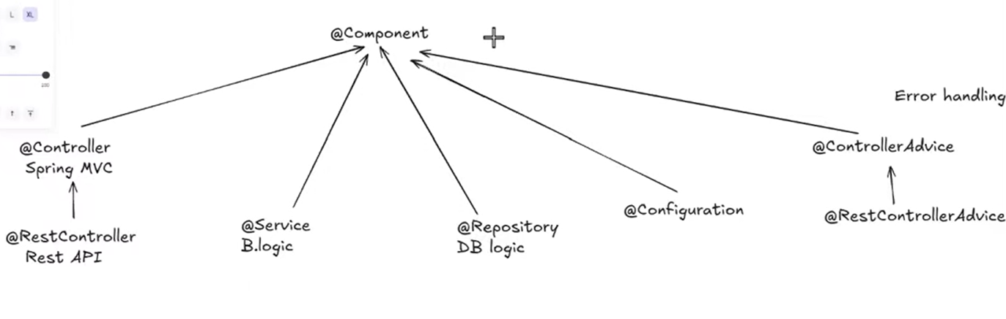

CODING SPRING AND SPRINGBOOT
(Week 2 – Day 3)

- Spring IoC Container – Key Concepts

Purpose: Spring manages objects (beans) via a container, handling their lifecycle, dependencies, and configuration.

Container Types: there are two type of

BeanFactory – the lightweight, basic container; suitable for minimal memory footprint applications; provides core IoC features.

ApplicationContext – advanced, feature-rich container; supports internationalization, events, AOP, and more; default in modern Spring applications including Spring Boot.

Practical Insight: In real-world usage, almost all applications rely on ApplicationContext. BeanFactory is rarely used in current projects.

Tip for Interviews: Always mention ApplicationContext as default, and highlight the extra features it provides over BeanFactory.

- Lombok

A Java library that automatically generates boilerplate code like getters, setters, constructors, toString(), equals(), and hashCode() at compile-time using annotations (e.g., @Getter, @Setter, @AllArgsConstructor). It simplifies code, reduces errors, and improves readability without writing repetitive methods manually.

In Eclipse, using Lombok typically involves two steps:
- Add the Lombok dependency to your pom.xml (or build file).
- Install/enable the Lombok plugin in the IDE so it recognizes the annotations and generates code correctly.
In IntelliJ, usually adding the dependency and enabling annotation processing is enough.

Here’s a final, concise, interview-ready list of all commonly used Lombok annotations, focusing on constructors and essentials:

Lombok Annotations – Key Ones for Constructors and Common Use
Constructor Annotations:
- @NoArgsConstructor → Generates a no-argument constructor. Useful for frameworks like JPA that require a default constructor.
- @AllArgsConstructor → Generates a constructor with all fields as parameters. Quick way to initialize the entire object.
- @RequiredArgsConstructor → Generates a constructor for all final fields and fields annotated with @NonNull. Ensures mandatory fields are initialized.
Other Common Annotations:
- @Getter / @Setter → Automatically generates getter and setter methods for fields.
- @ToString → Generates a toString() method including all fields.
- @EqualsAndHashCode → Generates equals() and hashCode() methods based on fields.
- @Data → Shortcut for @Getter, @Setter, @ToString, @EqualsAndHashCode, and @RequiredArgsConstructor.
- @Builder → Implements the Builder pattern for object creation.
- @NonNull → Adds null checks to fields or parameters and works with @RequiredArgsConstructor.
✅ Tip: Using Lombok reduces boilerplate code, improves readability, and is widely used in Spring Boot projects.

Why Spring Needs @NoArgsConstructor of Lombok Even Though Java Provides a Default Constructor ?

✅ @NoArgsConstructor – Key Points
1️⃣ Java Default Constructor
- If no constructor is defined, Java provides a default no-argument constructor.
- Spring or JPA can use this automatically.
2️⃣ Problem When Other Constructors Are Defined
- If you define any constructor (e.g., @AllArgsConstructor or a custom one), the compiler does not generate the default no-arg constructor.
- Without a no-arg constructor, frameworks like Spring or JPA cannot create objects automatically.
3️⃣ Why Frameworks Need a No-Arg Constructor
- Reflection is a general Java mechanism that allows a program to inspect and manipulate classes, methods, fields, and constructors at runtime.
- Since we can’t make changes to a class directly at runtime, frameworks use reflection to create a new instance of the class using its default constructor and then dynamically set or modify its fields.
- Many frameworks, including Spring, Hibernate, and JPA, use reflection to create objects dynamically.
- JPA specifically: Reflection is used to instantiate entity objects automatically when reading from the database. JPA calls the no-argument constructor via reflection to create an empty object, then populates its fields with data from the table.
- Without a no-arg constructor, JPA cannot create the entity, because it relies on reflection, not your custom constructors.
4️⃣ How @NoArgsConstructor Helps
- Ensures a no-argument constructor exists even if you define other constructors.
- Avoids errors during bean creation or entity instantiation.
Example:
@Data
@AllArgsConstructor
@NoArgsConstructor
@Entity
public class User {
private Long id;
private String name;
}
Without @NoArgsConstructor, JPA would fail because @AllArgsConstructor removes the default constructor.
5️⃣ Rule of Thumb
- Whenever you define any constructor but still need framework-based instantiation (Spring/JPA/Hibernate), always add @NoArgsConstructor.

✅ Summary for Interview:
@NoArgsConstructor creates a no-argument constructor required by frameworks that use reflection, including Spring, Hibernate, and JPA. Reflection allows frameworks to dynamically create objects at runtime because we cannot modify a class directly while running. Without a no-arg constructor, any custom constructor prevents automatic object creation. For JPA, this ensures entity objects can be instantiated from database records.

- Avoiding Cyclic Dependencies in Spring

- Cyclic dependency occurs when two or more beans depend on each other directly or indirectly, forming a loop.
- Example to avoid:
  - Controller depends on Service → @Autowired Service service
  - Service depends on Controller → @Autowired Controller controller
This creates a cycle and causes Spring to fail during bean initialization.
- Spring’s DI flow:
  - Spring tries to create the Controller bean.
  - It sees the Controller depends on AddServiceImpl.
  - Spring creates AddServiceImpl and injects it into the Controller.
  - If AddServiceImpl again depends on Controller (cycle), Spring cannot resolve it → application fails.
- Rule of thumb:
  - Never let Controller DI Service and Service DI Controller.
  - Avoid cycles even in long chains of beans.
  - Design dependencies in one direction for safe bean creation.
- Key takeaway: Understanding and preventing cyclic dependencies is crucial for Spring applications. Use Lombok or other DI tools carefully, but cyclic DI must always be avoided.

- Spring IoC Containers and the Special ApplicationContext Bean

Spring has a main container for managing beans. Originally, this was the BeanFactory, which provides basic IoC features but is rarely used today. To add advanced capabilities (like events, AOP, internationalization) without losing the basic features, Spring introduced ApplicationContext.
ApplicationContext now acts as the main container in modern Spring and Spring Boot apps.
Inside the ApplicationContext container, Spring also creates a special bean of type ApplicationContext. This is essentially a reference to the container itself, allowing you to access any other bean dynamically. So yes — the container and the special bean have the same type, but the bean is just an instance you can use programmatically.

In short:
- BeanFactory – old, basic container, rarely used.
- ApplicationContext – main container now, has all BeanFactory features + advanced ones.
- Special ApplicationContext bean – lets you access beans dynamically; same type as container, but it’s a bean inside the container.

Here’s a polished, interview-ready version including the special ApplicationContext bean part:

✅ Spring ApplicationContext and Beans
- BeanFactory – the original Spring container; lightweight, provides only basic IoC features; rarely used in modern applications.
- ApplicationContext – the advanced, main container in Spring and Spring Boot; includes all BeanFactory features plus support for events, AOP, internationalization, and more.
Special ApplicationContext Bean
- Inside the ApplicationContext container, Spring creates a special bean of type ApplicationContext.
- This bean is essentially a reference to the container itself, allowing you to access any other bean dynamically.
- Example use case: you can fetch a bean by type or name at runtime:
@Autowired
private ApplicationContext context;

MyService myService = context.getBean(MyService.class);
- Even when using interface references, Spring looks in the container to find the concrete implementation and injects it automatically.

✅ Summary for Interview:
ApplicationContext is the main Spring container, holding all beans. Inside it, a special ApplicationContext bean allows dynamic access to other beans, while interface-based injection lets Spring resolve and inject the correct implementation automatically.

- What Happens Internally When log.error() Logs an Exception in Spring Boot?

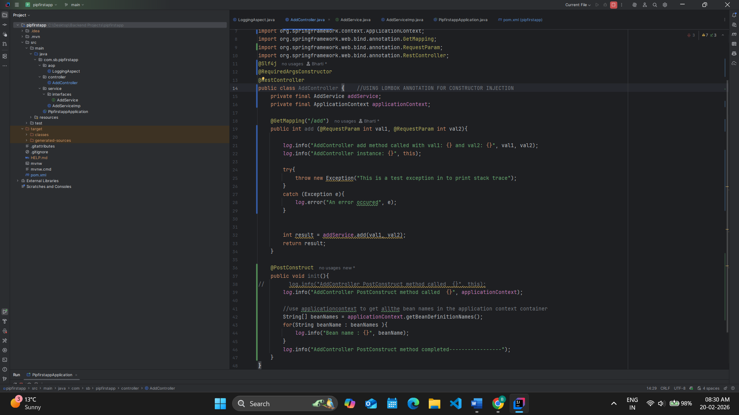

In this code, the stack trace is printed because we pass the exception object to the logger using:
log.error("An error occurred", e);
When we provide the exception as a parameter, the logging framework (SLF4J with Logback in Spring Boot) automatically prints the full stack trace.
Internally, the flow works like this:
- The log.error() call is made in your application code.
- SLF4J receives the logging request because it provides the logging API.
- SLF4J delegates the request to the actual logging implementation (Logback by default in Spring Boot).
- Logback processes the log event.
- Since an exception object is passed as the second parameter, Logback extracts and prints the complete stack trace.
A stack trace shows:
- The exception type
- The exception message
- The exact line where it occurred
- The complete method call chain that led to the error
In this case, the first important line in the stack trace is:
at com.sb.pipfirstapp.controller.AddController.add(AddController.java:41)
This tells us the exception originated inside the add() method at line 41.
The remaining lines show how Spring internally invoked the controller method through the DispatcherServlet, which is part of the Spring MVC request handling flow.
So in summary:
The logger prints the stack trace because the exception object is passed to log.error(). SLF4J forwards the request to Logback, and Logback prints the complete stack trace, which helps us identify exactly where and how the error occurred.

Why Are We Writing “SLF4J with Logback”? Can’t We Say Only SLF4J?
You cannot say only SLF4J, because SLF4J does not actually log anything.
SLF4J is only a logging facade, meaning it provides the logging interface and defines methods like log.info(), log.error(), and log.debug(), but it does not actually print logs, write them to files, format them, or handle stack traces. It simply defines how logging calls should look in the code.
The actual logging work is performed by a concrete logging framework such as:
- Logback
- Log4j
- Log4j 2
These frameworks process the log message, apply formatting, handle log levels, and output the logs to the console or files.
Logback is preferred because Spring Boot uses it as the default logging implementation, it integrates seamlessly with SLF4J, and it provides good performance with simple configuration. Log4j 1 is outdated and no longer recommended. While Log4j 2 is powerful and high-performance, Logback is sufficient, stable, and easier to use for most applications.
So technically correct wording is:
We use SLF4J as the logging facade and Logback as the logging implementation.

- 🔥 Complete API Lifecycle: Request → Response

🟢 1️⃣ Client Sends HTTP Request
The request may come from:
- Browser
- Postman
- Mobile app
- Another backend service
Example:
GET /users/1
The request travels over HTTP and reaches your application server.

🟢 2️⃣ Embedded Servlet Container Receives Request
Spring Boot runs with an embedded server like:
- Apache Tomcat
- Jetty
- Undertow
The server:
- Accepts the HTTP request
- Converts it into HttpServletRequest and HttpServletResponse objects
Now the servlet lifecycle begins.

🟢 3️⃣ Filters Execute (Before Controller)
Before reaching Spring MVC, Servlet Filters execute.
Examples:
- Logging filter
- CORS filter
- Compression filter
If security is enabled:
👉 Spring Security filter chain runs here.
This is where:
- Authentication happens
- Authorization is validated
- JWT tokens are checked
If authentication fails → request stops here.

🟢 4️⃣ Request Reaches DispatcherServlet
All requests go to:
👉 DispatcherServlet
This is the Front Controller of Spring MVC.
It coordinates the entire request handling process.

🟢 5️⃣ Handler Mapping
DispatcherServlet asks:
👉 Which controller method matches this URL?
Spring checks:
- @RequestMapping
- @GetMapping
- @PostMapping
HandlerMapping identifies:
UserController.getUser()

🟢 6️⃣ Interceptor (PreHandle)
If you have HandlerInterceptor:
- preHandle() executes
- It can block execution by returning false
Used for:
- Logging
- Audit
- Custom validation

🟢 7️⃣ Argument Resolution
Before calling the controller:
Spring prepares method parameters:
- @PathVariable
- @RequestParam
- @RequestBody
If JSON body is present:
Spring uses
👉 Jackson
to convert:
JSON → Java Object

🟢 8️⃣ Controller Method Executes
Now your controller finally runs:
@GetMapping("/users/{id}")
public User getUser(@PathVariable Long id) {
return userService.findById(id);
}
Business logic happens here.

🔵 Now the Response Flow Begins

🔵 9️⃣ Return Value Goes Back to DispatcherServlet
Controller does not send response directly.
The return value is passed back to DispatcherServlet.

🔵 1️⃣0️⃣ Return Type Handling
Spring checks:
- Is it String?
- Is it ModelAndView?
- Is it ResponseEntity?
- Is it a POJO object?
If using @RestController, Spring treats return value as response body.

@RestController ensures that the return value is written directly to the HTTP response body instead of resolving a view. However, the returned object is still a Java object. Since HTTP responses must be in formats like JSON or XML, Spring uses HttpMessageConverters to convert the object into JSON using Jackson before sending it to the client.

🔵 1️⃣1️⃣ HttpMessageConverter Converts Object
Spring uses HttpMessageConverters.
For JSON:
Java Object → Jackson → JSON
Example output:
{
"id": 1,
"name": "Bharti"
}

🔵 1️⃣2️⃣ HTTP Status and Headers Are Set
Spring sets:
- Status code (200 OK by default)
- Content-Type: application/json
- Custom headers (if defined)
If returning ResponseEntity, status and headers are taken from it.

🔵 1️⃣3️⃣ Interceptor Post Methods Execute
If interceptors exist:
- postHandle() runs
- afterCompletion() runs after rendering completes

🔵 1️⃣4️⃣ Filters Complete Execution
Filters resume execution after controller finishes.
Example:
- Logging filter calculates response time
- Security context is cleared

🔵 1️⃣5️⃣ Response Sent Back to Client
Response flows back:
DispatcherServlet
↓
Servlet Container (Tomcat)
↓
HTTP Response
↓
Client
API lifecycle complete.

🧠 Complete Visual Flow
Client
↓
Embedded Server (Tomcat)
↓
Filters (Security, CORS, Logging)
↓
DispatcherServlet
↓
HandlerMapping
↓
Interceptor (preHandle)
↓
Argument Resolution
↓
Controller
↓
DispatcherServlet
↓
MessageConverter (Jackson → JSON)
↓
Interceptor (postHandle / afterCompletion)
↓
Filters (after)
↓
HTTP Response to Client

🎯 Strong Interview Answer (Concise Version)
An API request first reaches the embedded servlet container like Tomcat, which forwards it to the DispatcherServlet. Filters and security checks execute before the controller. DispatcherServlet uses HandlerMapping to find the correct controller method and resolves arguments. After the controller returns, HttpMessageConverters convert the response object into JSON using Jackson. Finally, interceptors and filters complete execution, and the HTTP response is sent back to the client.

- 🔥 What Happens When an Exception Occurs?

Suppose this controller:
@GetMapping("/users/{id}")
public User getUser(@PathVariable Long id) {
return userService.findById(id); // throws RuntimeException
}
Now imagine findById() throws an error.

1️⃣ Error Happens
The error can happen:
- Inside service
- Inside controller
- While converting data
- While reading request
As soon as the error happens, normal execution stops.
The error goes back to the main Spring component called:
👉 DispatcherServlet

2️⃣ DispatcherServlet Catches the Error
Spring does NOT crash.
DispatcherServlet catches the error safely.
Then it asks:
👉 “Is there anyone who can handle this error?”

3️⃣ Spring Checks for Error Handlers
Spring checks in this order:
- Is there an @ExceptionHandler in this controller?
- Is there a global handler using @ControllerAdvice?
- If not, use default Spring Boot error handling.

4️⃣ If You Wrote @ExceptionHandler
If you wrote something like:
@ExceptionHandler(UserNotFoundException.class)
public ResponseEntity<String> handleUserNotFound(UserNotFoundException ex) {
return ResponseEntity.status(404).body("User not found");
}
Spring will call this method and return this response.
So instead of crashing, it sends a proper message to the client.

5️⃣ If You Wrote @ControllerAdvice
If no local handler exists, Spring checks global handlers:
@ControllerAdvice
public class GlobalExceptionHandler {

@ExceptionHandler(Exception.class)
public ResponseEntity<String> handleAll(Exception ex) {
return ResponseEntity.status(500)
.body("Something went wrong");
}
}
This works for all controllers.

6️⃣ If You Did Nothing
If you did not write any exception handler:
Spring Boot uses its default error controller called:
👉 BasicErrorController
It automatically sends a JSON error response like:
{
"timestamp": "...",
"status": 500,
"error": "Internal Server Error",
"path": "/users/1"
}

7️⃣ JSON Conversion
The error message is converted to JSON using:
👉 Jackson
Then it is sent back to the client.

🧠 Important
Even when error happens:
- Interceptors still finish
- Filters still finish
- Logging still happens
- Server does not stop

🔥 Simple Flow
Error happens
↓
DispatcherServlet catches it
↓
Spring checks for @ExceptionHandler
↓
Then checks @ControllerAdvice
↓
If none → Default error handling
↓
Error converted to JSON
↓
Response sent to client

🎯 Simple Interview Answer
When an exception occurs in a Spring Boot application, it is caught by the DispatcherServlet. Spring first checks for local @ExceptionHandler methods, then global @ControllerAdvice handlers. If none exist, Spring Boot uses its default error controller to send a structured JSON error response to the client.
- In a Spring Boot API, different types of errors (exceptions) can happen at different stages.

1️⃣ Input Validation Errors
These happen when the user sends wrong or incomplete data.
Example:
- Required field is missing
- Email format is wrong
- Age is negative
Spring usually returns 400 Bad Request.

2️⃣ Wrong Data Type Errors
These happen when the type does not match.
Example:
If API expects a number:
/users/10
But user sends:
/users/abc
Spring cannot convert "abc" into a number, so it throws an error.

3️⃣ Wrong HTTP Method
Example:
- API is GET
- User sends POST
Spring throws an error like “Method Not Allowed”.

4️⃣ Business Logic Errors
These are custom errors written by you.
Example:
- User not found
- Product out of stock
You usually create your own exception for this.

5️⃣ Database Errors
These happen when something goes wrong while saving or reading data.
Example:
- Duplicate value
- Data too long
- Record not found

6️⃣ Programming Errors
These are mistakes in code.
Example:
- NullPointerException
- Dividing by zero
These usually return 500 Internal Server Error.

7️⃣ Security Errors
If using Spring Security:
Example:
- Not logged in → 401
- No permission → 403

Simple Summary
In simple words, exceptions can happen because of:
- Wrong input
- Wrong data type
- Wrong request method
- Business rule failure
- Database problem
- Coding mistake
- Security issue

Interview Simple Answer
In a Spring Boot API, exceptions can happen due to invalid input, wrong data type, business logic errors, database problems, security issues, or coding mistakes. Spring handles them using exception handlers or its default error mechanism.

- How to implement dependency lookup ?

🔎 What is Dependency Lookup?
Dependency Lookup means:
👉 The object itself goes and asks the container for the dependency.
Instead of Spring automatically giving it (like in Dependency Injection),
the object manually “looks up” the dependency from the Spring container.

🧠 Simple Difference
Dependency Injection (DI)
Spring gives the dependency automatically.
Dependency Lookup (DL)
Your code asks Spring to give the dependency.

📁 Project Structure
com.example.demo
│
├── DemoApplication.java
├── controller
│ └── UserController.java
└── service
└── UserService.java

1️⃣ Service Layer
📄 File: service/UserService.java
package com.example.demo.service;

import org.springframework.stereotype.Service;

@Service
public class UserService {

public String getUser() {
return "User fetched successfully";
}
}
This is a normal Spring service bean.

2️⃣ Controller Layer (Using Dependency Lookup)
📄 File: controller/UserController.java
package com.example.demo.controller;

import com.example.demo.service.UserService;
import org.springframework.beans.factory.annotation.Autowired;
import org.springframework.context.ApplicationContext;
import org.springframework.web.bind.annotation.GetMapping;
import org.springframework.web.bind.annotation.RestController;

@RestController
public class UserController {

@Autowired
private ApplicationContext context; // Getting Spring container

@GetMapping("/user")
public String getUser() {

// 🔎 Dependency Lookup happening here
UserService userService = context.getBean(UserService.class);

return userService.getUser();
}
}
👉 Here the controller is manually asking the container:
“Give me UserService bean.”
This is Dependency Lookup.

3️⃣ Main Application
📄 File: DemoApplication.java
package com.example.demo;

import org.springframework.boot.SpringApplication;
import org.springframework.boot.autoconfigure.SpringBootApplication;

@SpringBootApplication
public class DemoApplication {

public static void main(String[] args) {
SpringApplication.run(DemoApplication.class, args);
}
}
This starts the Spring Boot application.

🔥 What Happens When You Call:
GET http://localhost:8080/user
Flow:
- Request reaches controller
- Controller asks ApplicationContext for UserService
- Spring container returns the bean
- Service method executes
- Response sent to client

🧠 Important Note
Normally we would write:
@Autowired
private UserService userService;
That is Dependency Injection (recommended).
But in this example we manually called:
context.getBean(UserService.class);
That is Dependency Lookup.

🎯 Interview One-Line Answer
In Dependency Lookup, the controller retrieves the service bean manually from the ApplicationContext using getBean(), instead of letting Spring inject it automatically.

- How Spring Uses Reflection and What Should Be Private or Public ?

In Java, fields should always be kept private to maintain encapsulation. This protects the internal state of the class and prevents other classes from directly modifying variables. Even though the fields are private, the Spring Framework can still inject dependencies into them because it uses reflection. Reflection allows Spring to access and modify private fields during object creation, even though normal Java code cannot access them directly.
Methods should be public only if they are meant to be used by other classes. If a method is only for internal logic within the class, it should be private. This keeps the class design clean and prevents unintended usage.
Constructors are different. Spring needs to create the object first, so constructors should generally be public (or at least not private). While reflection can technically access private constructors, using private constructors for Spring-managed beans is not recommended because it can prevent proper instantiation during component scanning. Constructor injection with a public constructor is considered best practice.
In short:
Fields → keep private for encapsulation.
Methods → public only if they must be accessed from outside.
Constructors → usually public so Spring can create the bean properly.

- Java Platform Independence, Runtime, and Reflection Explained

Computers do not understand Java language directly. They only understand very low-level instructions written in 0s and 1s. These instructions are called machine code.
Different computers use different types of processors (CPUs). Each processor understands its own specific type of machine instructions. Even though everything is written in 0s and 1s, the pattern and meaning of those 0s and 1s differ depending on the processor architecture (for example, x86 or ARM). Operating systems also differ in how programs interact with them.
If a programming language converts code directly into machine code, that machine code is created for one specific processor and operating system. That means the program may not work on another system. In such cases, you would need to create separate compiled versions for Windows, Linux, macOS, or different CPU types. This situation is called platform dependent, because the compiled program depends on a specific platform.
Platform independence means you write and compile your program once, and it runs on different systems without changing the source code or recompiling it for each system.
Java solves this problem in a different way. Instead of converting Java code directly into machine code, Java first converts it into an intermediate format called bytecode.
The flow is:
Java source code → Bytecode (.class file) → JVM → Machine code → Execution by CPU
Bytecode is a universal format. It is not tied to any specific operating system or processor type. The same bytecode file can be used on different systems.
Each system has its own JVM (Java Virtual Machine). The JVM is responsible for taking the bytecode and converting it into machine code that matches that specific processor and operating system. Then the CPU executes that machine code.
So you compile your Java program only once into bytecode. Then each system’s JVM handles converting that bytecode into the correct machine code for that system. Your program does not change — only the JVM differs per system.
The JDK (Java Development Kit) is also different for different systems because it contains the JVM. Since the JVM must match the operating system and processor, the JDK must also be built specifically for:
- Windows (x86)
- Linux (x86)
- macOS (Intel)
- macOS (Apple Silicon ARM)
However, your Java source code remains exactly the same across all platforms.
So the final understanding is:
Your Java code → Same everywhere
Bytecode → Same everywhere
JVM and JDK → Different for each system
Java achieves platform independence because your program is compiled into bytecode once, and the JVM on each system adapts that bytecode into machine code suitable for that system.
In simple terms:
Java does not change your program for each computer.
The JVM changes itself to run your program.

Runtime is the period when your program is actually executing. In Java, you first write your code (.java file), then compile it into bytecode (.class file) using the compiler. This compilation step checks syntax, types, and structure but does not run the program. When you run the program, the JVM starts reading the bytecode, converts it into machine code specific to your operating system and CPU, and the JRE executes it. All of this — from the moment JVM starts executing bytecode until the program finishes — is called runtime. During runtime, Java can also use reflection, which allows the program to inspect classes, fields, methods, and annotations, and manipulate them dynamically even if they are private. This is how frameworks like Spring can automatically create objects (beans), inject dependencies, call methods, and read annotations. Reflection happens while the program is running, not before, and it is separate from normal execution where the program simply runs the compiled machine code. If Spring were not there, the JVM would still convert bytecode to machine code and the JRE would execute it, but dynamic inspection, injection, or annotation processing would not happen automatically.

- Understanding Reflection in Java: How and When It Works (Interview definition)

Reflection in Java – Key Points
Reflection is a Java feature that allows a program to inspect and manipulate classes, fields, methods, and annotations at runtime, even if they are private. Unlike normal execution, where the JVM simply converts bytecode to machine code and runs it, reflection lets the program look inside itself and modify behavior dynamically while it’s running.
Frameworks like Spring use reflection to:
- Automatically create objects (beans)
- Inject dependencies (@Autowired)
- Call methods
- Process annotations (@Service, @RestController)
Without Spring or explicit reflection code, the JVM just executes bytecode normally—no dynamic inspection or automatic injection happens.
In short:
- Normal execution → Runs the code.
- Reflection → Lets the code examine and control itself at runtime.
Reflection does not happen automatically in every Java program; it occurs only when invoked by your code or a framework.

- @Configuration and @Bean

In Spring Framework, there are two main ways to create beans:
- Using stereotype annotations like @Component, @Service, @Controller (component scanning)
- Using Java configuration class + @Bean method (manual configuration)
You already know the first one. Let’s clearly understand the second method.

1️⃣ Bean creation using @Configuration and @Bean
Instead of putting @Component on a class, you define the bean inside a configuration class.
Example:
import org.springframework.context.annotation.Bean;
import org.springframework.context.annotation.Configuration;

@Configuration
public class AppConfig {

@Bean
public MyService myService() {
return new MyService();
}
}
Now MyService becomes a Spring bean even if it does NOT have @Component.

2️⃣ What exactly is happening?
- @Configuration → tells Spring this class contains bean definitions.
- @Bean → tells Spring to execute this method and register the returned object in the container.
- The method name (myService) becomes the bean name by default.
So Spring internally does something like:
Create object → Put inside IOC container → Manage lifecycle

3️⃣ When do we use @Bean instead of @Component?
You use @Bean when:
✔ You cannot modify the class
Example: Third-party library class
By default, Spring cannot automatically manage a third-party class because we cannot add Spring annotations like @Component to it, so component scanning does not detect it and Spring does not know how to create its object.
In that case, we would have to manually create the object using new every time we need it, and Spring would not control its lifecycle, scope, or dependency injection.
That is why we use @Configuration and @Bean. By defining the third-party object inside a configuration class, we allow Spring to create it once, store it in the IOC container, manage its lifecycle, and inject the same managed instance wherever required instead of creating it repeatedly.
(make a config folder and then create a configuration class in that and use these 2 annotations)

@Bean
public ObjectMapper objectMapper() {
return new ObjectMapper();
}
You cannot add @Component to ObjectMapper because it belongs to external library.
EXPLANATION OF ABOVE POINT -
Take another example, Suppose you are using a library class like:
public class ExternalClient {
public ExternalClient(String apiKey) { }
}
If you do not register it as a Spring bean, then every time you need it, you must do:
ExternalClient client = new ExternalClient("key");
That means:
- Spring does NOT manage it
- No dependency injection
- No singleton guarantee
- No lifecycle management
- You manually create it everywhere
That’s what your mentor meant.

🔹 Now using @Configuration + @Bean
@Configuration
public class AppConfig {
@Bean
public ExternalClient externalClient() {
return new ExternalClient("key");
}
}
Now Spring:
- Creates it once (default = singleton)
- Stores it in IOC container
- Injects it wherever needed
- Manages its lifecycle
Now you can simply do:
@Service
public class OrderService {
private final ExternalClient externalClient;
public OrderService(ExternalClient externalClient) {
this.externalClient = externalClient;
}
}
No new keyword anywhere.
Spring injects it.

✔ You need custom object creation logic
@Bean
public RestTemplate restTemplate() {
RestTemplate rt = new RestTemplate();
rt.setConnectTimeout(5000);
return rt;
}
If creation needs configuration logic → @Bean is better.

✔ You want full control over instantiation
You can inject dependencies manually:
@Bean
public OrderService orderService(PaymentService paymentService) {
return new OrderService(paymentService);
}
Spring automatically injects PaymentService here.

EXPLANATION OF ABOVE POINT -
Good doubt, You’re asking:
If Spring is automatically injecting PaymentService into the @Bean method… then where is the “full control” part?
Let’s break this carefully.

First: What actually happens here?
@Bean
public OrderService orderService(PaymentService paymentService) {
return new OrderService(paymentService);
}
Spring does:
- Look inside IOC container
- Find PaymentService bean
- Pass it as parameter
- You return a fully constructed OrderService
So yes — dependency injection is still automatic.
You are correct.

Then what does “full control” actually mean?
It does NOT mean manual dependency injection.
It means:
You control:
- How the object is created
- Which constructor is used
- Whether extra logic runs
- Whether conditions apply
- Whether different implementations are chosen
- Whether configuration values are applied
- Whether it is singleton/prototype
- Whether wrapping/proxying happens
That level of control.

Example : Conditional Logic
@Bean
public PaymentService paymentService() {
if (isProdEnvironment()) {
return new RazorpayService();
} else {
return new DummyPaymentService();
}
}
You cannot do this with @Component.

So your intuition is correct
For simple services like:
@Service
public class OrderService {
private final PaymentService paymentService;

public OrderService(PaymentService paymentService) {
this.paymentService = paymentService;
}
}
👉 @Component is enough.
You do NOT need @Bean.

4️⃣ Difference between @Component and @Bean
@Component | @Bean
Class level annotation | Method level annotation
Auto-detected by component scan | Explicitly declared
Less control | Full control
Used for application classes | Used for external or complex setup

5️⃣ Important: Proxy behavior
@Configuration classes are special.
Spring creates a proxy of that class to ensure:
- If one @Bean method calls another, it does not create a new object.
- It returns the same singleton bean.
Example:
@Bean
public A a() {
return new A(b());
}

@Bean
public B b() {
return new B();
}
Even though b() is called directly, Spring ensures only one B bean exists.

6️⃣ In Spring Boot
In Spring Boot, you mostly use @Component, but internally Spring Boot heavily uses @Configuration and @Bean for auto-configuration.

Final Simple Understanding
Think like this:
- @Component → "Spring, scan and create this class automatically."
- @Bean → "Spring, I will create the object, you just manage it."
Or
We can say,
@Bean is NOT for basic dependency injection.
It is for:
Manual object creation with custom logic before Spring manages it.

-@Configuration & @Bean
When to use, and how it works step by step.
Example of Random

-Spring Boot
- Extended on top of Core Spring Framework
- Rapid application development
- Developers have to make minimal changes.
- Easy to setup & easy to use.
- Any type of project which can be developed in spring ecosystem can be developed using spring boot.
- Market adoption of spring framework massive grew.
1. AutoConfiguration
2. Spring boot Starters

- Spring Boot for interviews

✅ How to Answer: “What is Spring Boot?”
Spring Boot is an extension built on top of the Spring Framework. It was introduced to simplify and speed up application development in the Spring ecosystem.
It enables rapid application development by reducing boilerplate configuration. Developers don’t need to manually configure most of the infrastructure. It is easy to set up, easy to use, and production-ready by default. Any application that can be built using the Spring ecosystem can also be built using Spring Boot, but with much less configuration effort. Because of this simplicity and productivity boost, adoption of Spring in the industry grew massively.

📌 Spring Boot Key Features
From official features:
- Rapid Application Development
- Auto-configuration of Spring & third-party libraries
- Opinionated starters
- Embedded servers (Tomcat, Jetty, Undertow)
- Production-ready features (metrics, health checks)
- Logging support
- Unit testing support
- DevTools
- Stand-alone applications
- No XML configuration required

✅ Then Move to Core Features
After basic definition, mention the two most important features:
- AutoConfiguration
- Spring Boot Starters
This shows depth.

🔹 1️⃣ AutoConfiguration (Very Important for Interview)
Spring Boot AutoConfiguration means:
Spring automatically configures your application based on the dependencies present in the classpath.
For example:
- If the project has a web dependency, it configures a web server.
- If JPA dependency is present, it configures EntityManager and DataSource.
- If Actuator is present, it configures health endpoints.
You do NOT need to manually write:
@Configuration
@Bean
for these infrastructure beans.

🔹 How It Works
- Spring Boot checks the jars available in the project classpath.
- Based on that, it loads predefined auto-configuration classes.
- It creates required beans automatically.
- These beans are registered inside the IOC container.
- You can directly use Dependency Injection.
This is called “sensible defaults”.
Meaning:
Spring provides production-ready default configurations based on industry best practices.

🔹 Important Interview Point
Spring Boot will auto-configure a bean only if you have NOT already defined it.
This works using condition annotations like:
@ConditionalOnMissingBean
Meaning:
👉 Create this auto-configured bean only if the developer has not created one manually.
So if you define:
@Configuration
@Bean
public HealthEndpoint healthEndpoint() {
return new HealthEndpoint();
}
Then Spring Boot will NOT create its own auto-configured HealthEndpoint bean.
Developer configuration always takes priority.
This shows that Spring Boot is flexible, not restrictive.

and

@ConditionalOnMissingBean means:
Create and register this bean only if no bean of the same type (or name) already exists in the Spring container.
In simple terms, Spring Boot will auto-configure a bean only when the developer has not defined one manually. If the developer creates their own bean, the auto-configuration backs off and does not create a duplicate.

As we have learned in microservices lecture, in design for failure point, that one of the mechanism followed is monitoring like monitoring the performance, health, etc. and this can be done by spring concept springboot actuator. And before seeing the example let’s clear a doubt first

Earlier we discussed that in core Spring, if we use a third-party class, Spring does not create its bean automatically because we cannot add annotations to that class. So we have to manually create the bean using @Configuration and @Bean if we want Spring to manage it.
Now in Spring Boot, this same process is handled by auto-configuration. Spring Boot internally provides those configuration classes and automatically creates the required beans based on the dependencies present in the classpath. So instead of us writing @Configuration and @Bean, Spring Boot writes and applies them internally. However, if we want custom logic while creating the bean, we can still define our own bean, and Spring Boot will back off and use our custom implementation.

Here is the example using HealthEndpoint.

When we add Spring Boot Actuator dependency (in Spring Boot), Spring Boot internally contains auto-configuration classes similar to this example. These classes use @Configuration, @Bean, and @ConditionalOnMissingBean to automatically create the HealthEndpoint bean and register it in the container.
So the class below is just a simplified representation of that class which Spring Boot already provides as its own internal auto-configuration for HealthEndpoint, and we do not write it manually.

1️⃣ Auto-Configuration Class
package com.example.autoconfig;

import org.springframework.context.annotation.Bean;
import org.springframework.context.annotation.Configuration;
import org.springframework.boot.autoconfigure.condition.ConditionalOnMissingBean;
import org.springframework.boot.actuate.health.HealthEndpoint;

@Configuration
public class HealthAutoConfiguration {

@Bean
@ConditionalOnMissingBean(HealthEndpoint.class)
public HealthEndpoint healthEndpoint() {
return new HealthEndpoint();
}
}

2️⃣ If Developer Creates Their Own Bean
package com.example.config;

import org.springframework.context.annotation.Bean;
import org.springframework.context.annotation.Configuration;
import org.springframework.boot.actuate.health.HealthEndpoint;

@Configuration
public class CustomHealthConfig {

@Bean
public HealthEndpoint healthEndpoint() {
return new HealthEndpoint(); // custom logic can be added here
}
}

✅ What Happens
- If the developer does NOT define HealthEndpoint, Spring Boot creates it automatically.
- If the developer defines their own HealthEndpoint bean, auto-configuration backs off because of @ConditionalOnMissingBean.
So only one HealthEndpoint bean will exist in the container.

🔹 2️⃣ Spring Boot Starters
Starters are dependency bundles.
Instead of adding multiple dependencies manually, you add one starter.
Example:
- spring-boot-starter-web
- spring-boot-starter-data-jpa
- spring-boot-starter-security
Each starter brings all required transitive dependencies needed for that feature.
This reduces dependency management complexity.

🎯 Final Polished Interview Answer (Short Version)
Spring Boot is built on top of the Spring Framework and is designed to simplify and accelerate application development. It reduces manual configuration by providing auto-configuration and starter dependencies. AutoConfiguration works by analyzing the jars present in the classpath and automatically creating required beans with sensible production-ready defaults. Developers do not need to manually configure infrastructure beans, and if they define their own bean, Spring Boot backs off using conditions like @ConditionalOnMissingBean. Starters further simplify development by grouping commonly used dependencies into a single dependency. This makes Spring Boot fast to develop, easy to maintain, and widely adopted in the industry.

- Explain the functionality of Springbootapplication run in main file

📌 @SpringBootApplication
It is a combination of:
- @Configuration
- @EnableAutoConfiguration
- @ComponentScan

🔹 @Component
Marks class as Spring Bean.

🔹 @ComponentScan
- Scans base package and subpackages.
- Finds classes annotated with:
  - @Component
  - @Service
  - @Repository
  - @Controller
  - @Configuration
- Registers them as beans.

🔹 @EnableAutoConfiguration
- Checks classpath for jars.
- Determines what beans need to be created.
- Uses conditional logic.
- If developer already created bean → AutoConfig backs off.
- Else → Spring Boot creates required beans.

🔹 Bean Creation Order
Spring Boot recognizes and creates beans in order:
- @Component
- @Configuration + @Bean
- @AutoConfiguration
After bean creation:
- Dependency Injection happens.
If everything succeeds:
- Spring container is ready.
If failure during startup:
- Application Failed to Start.

📌 @SpringBootTest
- Used in testing.
- Starts full Spring container.
- Tries to create all beans.
- If any dependency issue → test fails.
- Ensures application can start successfully.

📌 Clean Package
- Runs test cases.
- Verifies full application startup.
- Ensures dependencies are correct.

End-to-end working in IT - Agile - Jira - Git Branching
(Week 2 – Day 4)

Agile - Scrum
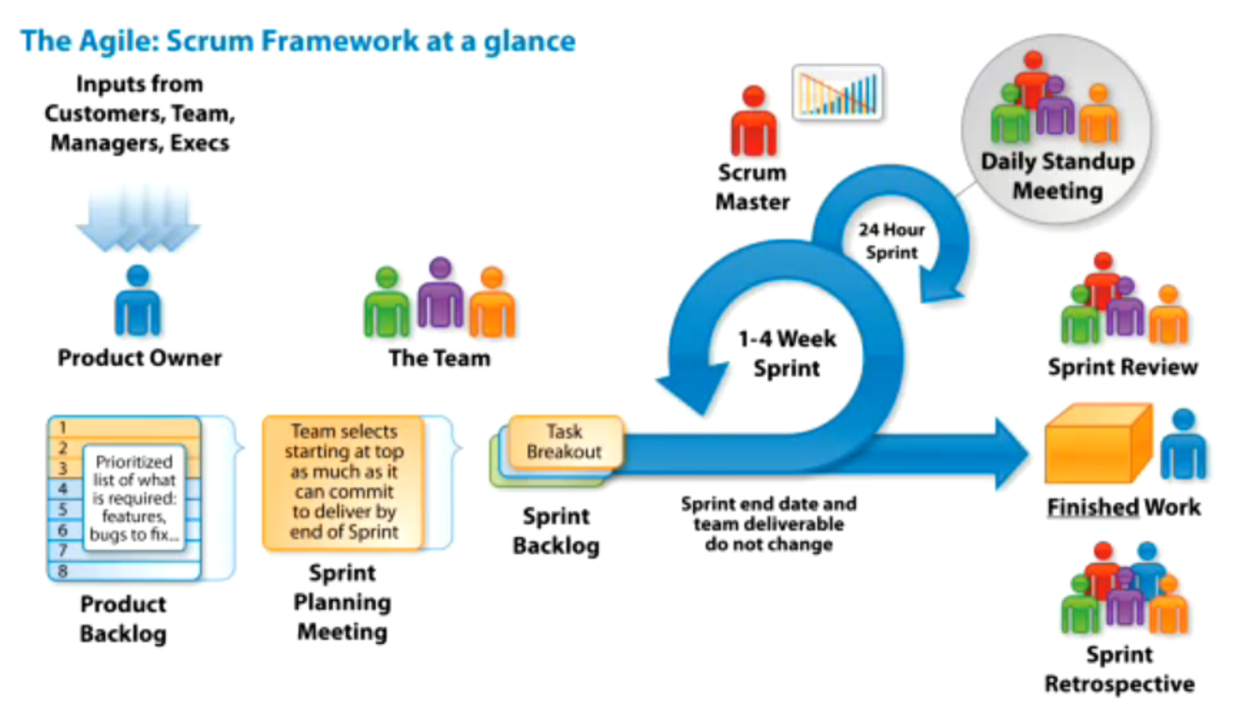

Common pool of Architects, DBA, devops which work across multiple projects. Team works focused on their project. For big teams, direct hire can also happen.
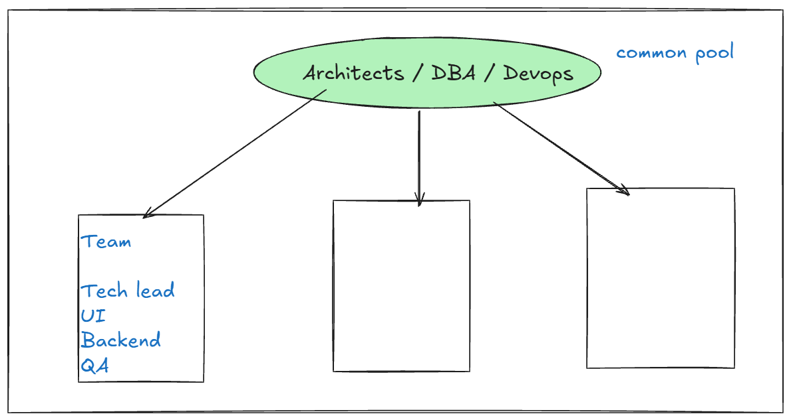

JIra backlog view
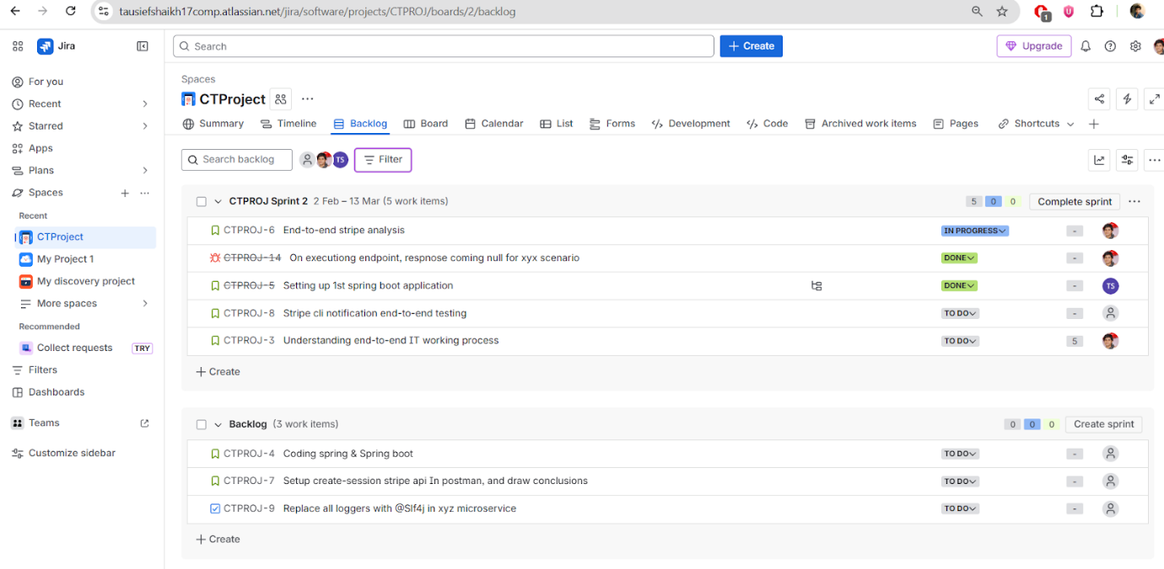

Technical working process in IT. Branching - cloud - local - AWS env
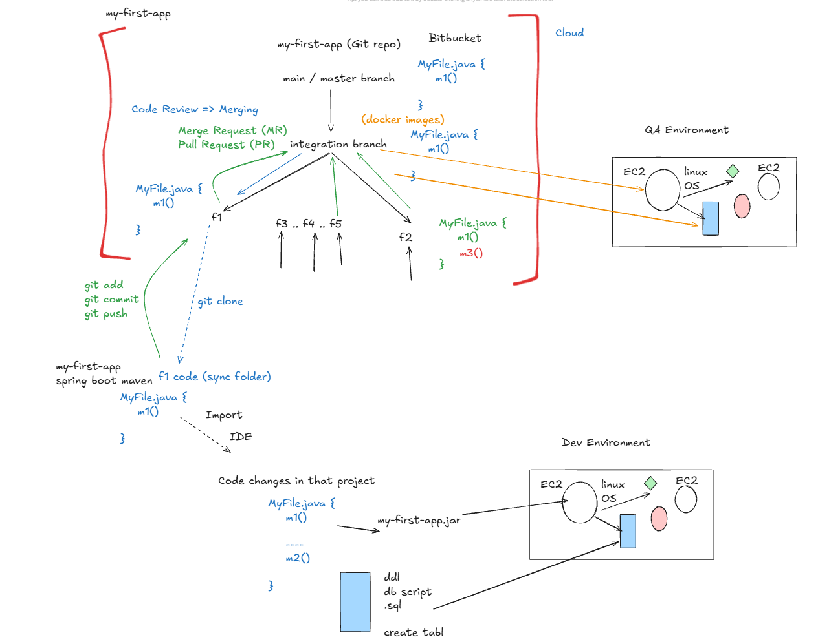

📌 Agile & Scrum
- Agile is a development methodology adopted widely after 2010.
- It is result-oriented and beneficial for client, employees, and company.
- Agile can be implemented using:
  - Scrum
  - Kanban
  - Scrumban
Roles in Agile
Product Owner (PO)
- Discusses requirements with business team.
- Converts business needs into technical requirements.
- Writes requirements in Jira as user stories.
- Prioritizes backlog items.
Scrum Master
- Coordinates team.
- Conducts daily standup.

📌 Jira & Backlog Process
- PO discusses requirements with business.
- Writes user stories in Jira.
- Backlog is prepared.
- Priority is decided.
- Grooming / Refinement meeting happens.
  - Dev team asks questions.
  - Story points estimated.
- Internal tech grooming.
  - Decide approach and high-level design.
- Final story point estimation.
👉 Requirement must be clear before coding.
👉 Requirement freeze during development.
👉 Think from business perspective.

📌 Sprint Planning
- Commit only what team can complete.
- Do not overcommit.
- Tickets assigned to developers.
- On Day 1:
  - Requirements clear
  - Design clear
  - Responsibility clear
  - Sprint scope clear

📌 Daily Standup
Each member tells:
- What was done yesterday
- What will be done today
- Any blockers

📌 Git & Version Control
- Every microservice must be a Git repository.
- Hosted on cloud (Bitbucket, GitHub).
- Common branches:
  - main
  - integration
  - feature branches
Development Flow
- Create feature branch from integration.
- Clone to local.
- Import in IDE.
- Start development.
- Test locally:
  - Manual testing
  - Postman API testing
  - Logging (SLF4J + Logback)
  - DB testing
  - End-to-end testing
- Write unit tests.
- Check profiles (local vs AWS dev).
- Push code regularly to feature branch in cloud.

📌 Merge & Testing Flow
- Raise Pull Request to integration branch.
- Code review.
- Fix review comments.
- Merge to integration.
- Resolve merge conflicts if needed.
- Deploy integration branch to QA environment.
  - CI/CD (Jenkins)
  - Manual deployment
  - Docker on EC2
- Tester tests in QA.
- Update Jira status.

📌 Bug Fix Flow
Option 1:
- Fix in feature branch → test → Pull req→ merge → QA deploy.
Option 2:
- Create separate bug-fix branch → same process.

📌 Deployment & Environments
- Local environment
- AWS Dev environment
- QA environment
- Production
Spring Boot profiles manage environment-specific configs.

Practical Working with Git, Bitbucket, SourceTree & Spring Boot Features
(Week 2 – Day 5)

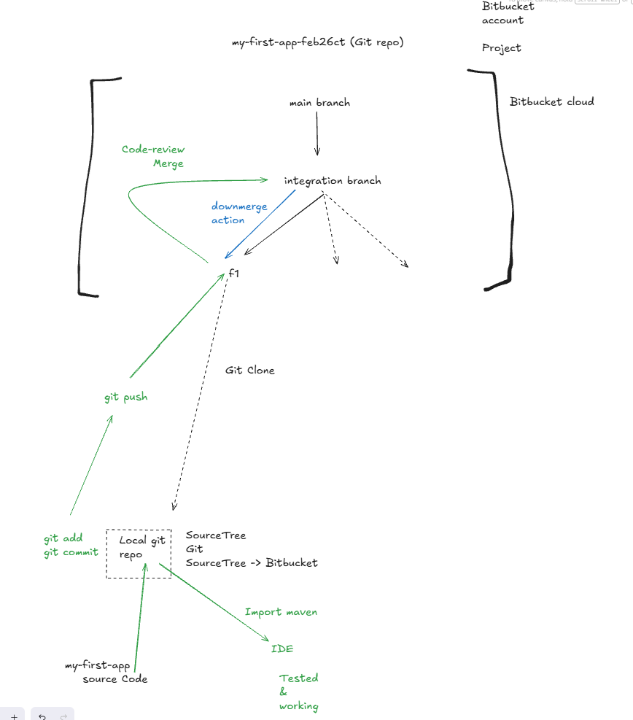

🔹 Practical Git Operations in Project
- Every change in the project is tracked by Git.
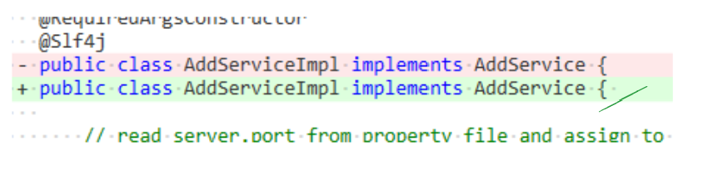

- SourceTree History Graph shows commit history across all branches.
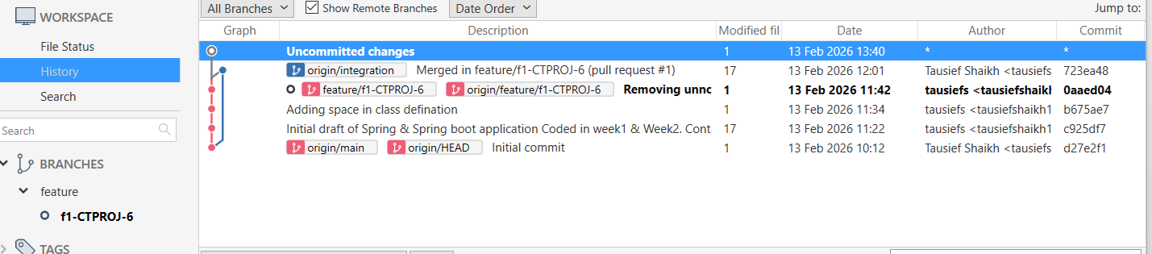
- Helps visualize merges, feature branches, integration flow.

🔹 Sprint Start – Development Flow
Day 1: Sprint Planning Meeting
You are assigned 2 microservices out of 5.
Each microservice has:
- Separate Git repository in Bitbucket
- main branch (default)
- integration branch (created from main)
For new development:
- Create feature branch from integration branch
- One feature branch per Jira requirement
- Naming format:
description_<jiraId>

🔹 Bitbucket Setup Process
- Create project in Bitbucket (Private).
- Create Git repository (microservice name = repo name).
- Ensure branches:
  - main
  - integration (created from main)

🔹 Local Machine Setup
Requirements:
- Git installed
- CLI or GUI tool
- SourceTree installed
Steps:
- Link Bitbucket account to SourceTree (OAuth or App Password).
- Clone feature branch to local machine.
- Maintain structured folder path for repositories.

🔹 Moving Existing Spring Boot Code to Git
- Copy Week1/Week2 Spring Boot Maven project into cloned feature branch folder.
- Import as existing Maven project in IDE.
- Execute and test locally.
- Now code is under Git tracking.

🔹 Git Basic Commands Flow
- git add → Stage changes
- git commit → Save changes in local repo
- git push → Move changes to cloud feature branch
Important:
- Push regularly even if development is ongoing.
- Feature branch changes do not affect others.

🔹 Pull Request & Code Review Flow
When feature is complete:
- Ensure:
  - Local testing complete
  - AWS Dev testing complete
  - 80% unit testing mandatory
- Raise Pull Request:
  - Source: Feature branch
  - Destination: Integration branch
- Add reviewers.
- Fix review comments if needed.
- Merge to integration branch.
Jira Integration:
- If branch name contains Jira ticket ID, Jira & Bitbucket link automatically.

🔹 Keeping Local Updated
If cloud changes happen:
- Use fetch in SourceTree.
- Pull latest updates into local machine.

🔹 Full New Feature Workflow Summary
- Sprint starts.
- Create feature branch from integration.
- Clone to local.
- Import in IDE.
- Execute & test.
- Start coding.
- Do local testing + unit testing + AWS dev testing.
- Commit & push regularly.
- Raise pull request.
- Code review.
- Merge to integration.

📌 Spring Boot Starters
Example starters:
- spring-boot-starter-webmvc
- spring-boot-starter-webmvc-test
- spring-boot-starter-actuator
What is a Starter?
A starter is a:
👉 Preconfigured dependency bundle
👉 Opinionated starter
It automatically provides:
- Main required jar files
- Dependent jars
- Relevant configuration jars
Spring Boot analyzes:
- What type of application you are building
- What dependencies you might need
- Adds them automatically to classpath

🔹 What Starters Provide
- Embedded Tomcat
- Logging support (SLF4J + Logback)
- Embedded database
- Unit testing + mocking
- Version compatibility management
- AutoConfiguration support
They manage:
- Version conflicts
- Dependency compatibility
- Transitive dependencies

